***ANUDIP FOUNDATION***

A Project Report on

**“ONLINE EXAMINATION SYSTEM”**

By

Batch: ANP-D0453

Student ID: AF0477118

Name: Harshada Hanmant Mane

**Under the Guidance of**

Mrs. Rajshri Chandrabhan Thete

**ONLINE EXAMINATION SYSTEM**

Introducing our Java-based ONLINE EXAMINATION SYSTEM(RMS):

Efficiently manage every aspect of your educational assessments with our intuitive **Online Examination System (OES)**. From creating and scheduling exams to evaluating performance and generating insightful reports, our OES empowers educational institutions to streamline the examination process and deliver a seamless experience to both instructors and students.

**Entities:**

* Admin
* Student
* Instructor
* Department
* Course
* Topic
* Exam
* Question
* Answer

**ATTRIBUTES OF ENTITIES:**

**1. Admin**

* Admin_ID (Primary Key)
* Name
* Email
* Password
* Role

**2. Student**

* Student_ID (Primary Key)
* Name (First, Last)
* Email
* Address
* Exam_ID (foreign key)
* Course_id (foreign key)

**3. Instructor**

* Inst_ID (Primary Key)
* Name
* Email
* Course_ID (foreign key)
* Dept_ID (foreign key)

**4. Department**

* Dept_ID (Primary Key)
* Dept_Name

**5. Course**

* + Course_ID (Primary Key)
  + Course Name
  + Description
  + Inst_ID (Foreign key)
  + Topic_ID (Foreign key)
  + Student_ID (Foreign key)

**6. Topics**

* + Topic_ID (Primary Key)
  + Topic Name

**7. Exam**

* Exam_ID (Primary Key)
* Time
* Number of Questions
* Admin_ID (foreign key)
* Student_ID (foreign key)

**8. Question**

* + Q_ID (Primary Key)
  + Question Text
  + Question Type (MCQ, True/False)
  + Associated with a Topic

**9. Answer**

* + Answer_ID (Primary Key)
  + Answer Text

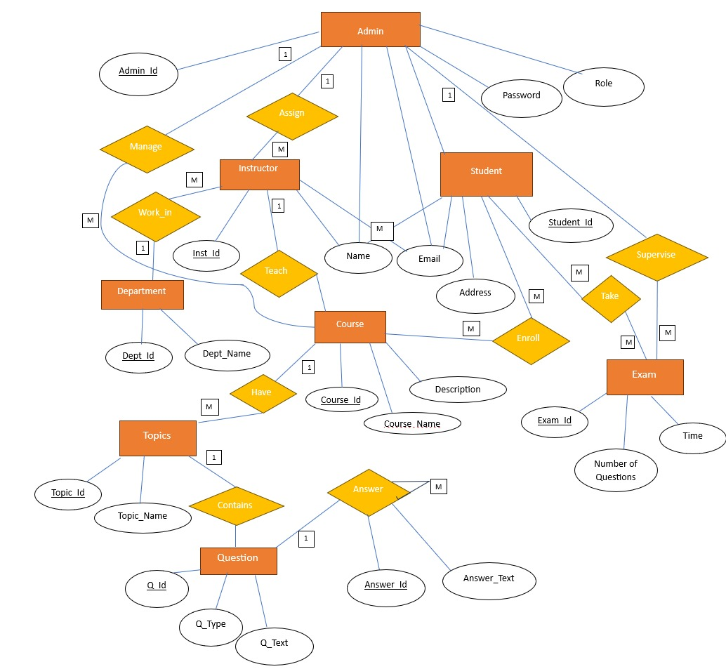

**CONCLUSION:**

In summary, our Java-based Online Examination System (OES) is a comprehensive solution designed to simplify and enhance the entire examination lifecycle. By integrating advanced features with a user-friendly interface, it not only improves efficiency for administrators and instructors but also ensures a smooth and accessible experience for students. With OES, institutions can confidently transition to a smarter, more organized, and reliable way of conducting assessments.

**DATABASE CREATION QUERY:**

mysql> use online_examination_system;

Database changed

mysql> show tables;

+-------------------------------------+

| Tables_in_online_examination_system |

+-------------------------------------+

| admins |

| answers |

| courses |

| departments |

| exams |

| instructors |

| questions |

| student_courses |

| student_exams |

| students |

| topics |

+-------------------------------------+

11 rows in set (0.00 sec)

mysql> create table admins;

ERROR 4028 (HY000): A table must have at least one visible column.

mysql> desc admins;

+----------+--------------+------+-----+---------+----------------+

| Field | Type | Null | Key | Default | Extra |

+----------+--------------+------+-----+---------+----------------+

| adminId | int | NO | PRI | NULL | auto_increment |

| email | varchar (255) | NO | UNI | NULL | |

| name | varchar (255) | NO | | NULL | |

| password | varchar (255) | NO | | NULL | |

| role | varchar (255) | NO | | NULL | |

+----------+--------------+------+-----+---------+----------------+

5 rows in set (0.00 sec)

mysql> desc answers;

+-------------+--------------+------+-----+---------+----------------+

| Field | Type | Null | Key | Default | Extra |

+-------------+--------------+------+-----+---------+----------------+

| answerId | int | NO | PRI | NULL | auto_increment |

| answerText | varchar (255) | NO | | NULL | |

| question_id | int | YES | MUL | NULL | |

| student_id | int | YES | MUL | NULL | |

+-------------+--------------+------+-----+---------+----------------+

4 rows in set (0.00 sec)

mysql> desc courses;

+---------------+--------------+------+-----+---------+----------------+

| Field | Type | Null | Key | Default | Extra |

+---------------+--------------+------+-----+---------+----------------+

| courseId | int | NO | PRI | NULL | auto_increment |

| courseName | varchar(255) | NO | UNI | NULL | |

| description | varchar(255) | NO | | NULL | |

| instructor_id | int | YES | MUL | NULL | |

+---------------+--------------+------+-----+---------+----------------+

4 rows in set (0.00 sec)

mysql> desc departments;

+----------+--------------+------+-----+---------+----------------+

| Field | Type | Null | Key | Default | Extra |

+----------+--------------+------+-----+---------+----------------+

| deptId | int | NO | PRI | NULL | auto_increment |

| deptName | varchar(255) | NO | UNI | NULL | |

+----------+--------------+------+-----+---------+----------------+

2 rows in set (0.00 sec)

mysql> desc exams;

+--------------+--------------+------+-----+---------+----------------+

| Field | Type | Null | Key | Default | Extra |

+--------------+--------------+------+-----+---------+----------------+

| examId | int | NO | PRI | NULL | auto_increment |

| duration | int | NO | | NULL | |

| numQuestions | int | NO | | NULL | |

| title | varchar(255) | NO | | NULL | |

| admin_id | int | YES | MUL | NULL | |

+--------------+--------------+------+-----+---------+----------------+

5 rows in set (0.00 sec)

mysql> desc instructors;

+--------------+--------------+------+-----+---------+----------------+

| Field | Type | Null | Key | Default | Extra |

+--------------+--------------+------+-----+---------+----------------+

| instructorId | int | NO | PRI | NULL | auto_increment |

| email | varchar(255) | NO | UNI | NULL | |

| name | varchar(255) | NO | | NULL | |

| dept_id | int | YES | MUL | NULL | |

+--------------+--------------+------+-----+---------+----------------+

4 rows in set (0.00 sec)

**mysql> desc questions;**

+--------------+--------------+------+-----+---------+----------------+

| Field | Type | Null | Key | Default | Extra |

+--------------+--------------+------+-----+---------+----------------+

| questionId | int | NO | PRI | NULL | auto_increment |

| questionText | varchar(255) | NO | | NULL | |

| questionType | varchar(255) | NO | | NULL | |

| exam_id | int | NO | MUL | NULL | |

| topic_id | int | YES | MUL | NULL | |

+--------------+--------------+------+-----+---------+----------------+

5 rows in set (0.00 sec)

**mysql> desc student_courses;**

+------------+------+------+-----+---------+-------+

| Field | Type | Null | Key | Default | Extra |

+------------+------+------+-----+---------+-------+

| student_id | int | NO | MUL | NULL | |

| course_id | int | NO | MUL | NULL | |

+------------+------+------+-----+---------+-------+

2 rows in set (0.00 sec)

**mysql> desc student_exams;**

+------------+------+------+-----+---------+-------+

| Field | Type | Null | Key | Default | Extra |

+------------+------+------+-----+---------+-------+

| exam_id | int | NO | MUL | NULL | |

| student_id | int | NO | MUL | NULL | |

+------------+------+------+-----+---------+-------+

2 rows in set (0.00 sec)

**mysql> desc students;**

+-----------+--------------+------+-----+---------+----------------+

| Field | Type | Null | Key | Default | Extra |

+-----------+--------------+------+-----+---------+----------------+

| studentId | int | NO | PRI | NULL | auto_increment |

| address | varchar(255) | NO | | NULL | |

| email | varchar(255) | NO | UNI | NULL | |

| firstName | varchar(255) | NO | | NULL | |

| lastName | varchar(255) | NO | | NULL | |

+-----------+--------------+------+-----+---------+----------------+

5 rows in set (0.00 sec)

**mysql> desc topics;**

+-----------+--------------+------+-----+---------+----------------+

| Field | Type | Null | Key | Default | Extra |

+-----------+--------------+------+-----+---------+----------------+

| topicId | int | NO | PRI | NULL | auto_increment |

| topicName | varchar(255) | NO | | NULL | |

| course_id | int | YES | MUL | NULL | |

+-----------+--------------+------+-----+---------+----------------+

3 rows in set (0.00 sec)

mysql>